Example 1  The $500 Kg$ engine is suspended from the crane boom as shown. Determine the resultant internal loadings acting on the cross section of the boom at points $E$ and $F.$  $$\tan{θ}=\frac{1.5}{2}≫≫ θ=37°$$ |  | 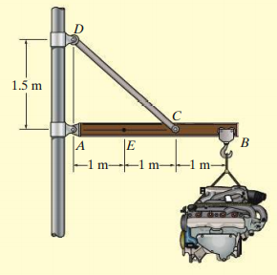  $$T$$  $$F$$
Consider the free body diagram of the boom AB.  $$ΣM_{A}=0 ≫≫ T\sin{θ}×2-4905×3=0≫≫T=12225.5 N$$  $$ΣF_{x}=0 ≫≫ X_{A}-T\cos{θ}=0≫≫X_{A}=9763.7 N$$  $$ΣF_{y}=0 ≫≫ Y_{A}+T\sin{θ-4905}=0≫≫Y_{A}=-2452.5 N$$ |  |  | 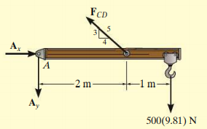  $$Y_{A}$$  $$X_{A}$$
To see the internal loading at E, let us cut the boom at E and consider the free body diagram of the left part.  $$X_{A}=9763.7 N$$  $$Y_{A}=2452.5 N$$  $$A$$  $$E$$  For equilibrium, at E, there should be forces equal and opposite to $X_{A}$ and $Y_{A}$ |  |  |  | $$X_{A}=9763.7 N$$  $$Y_{A}=2452.5 N$$  $$A$$  $$E$$  $$Y_{E}$$  $$X_{E}$$  $$M_{E}$$  $$1 m$$
Now, the forces are balanced, but the two equal parallel vertical forces at A and E produces a couple in the ccw direction. Therefore, the forces in the cross-section at E should also produce a clockwise couple for the equilibrium.
$$ΣF_{x}=0 ≫≫ X_{A}-X_{E}=0≫≫X_{E}=9763.7 N$$
$$ΣF_{y}=0 ≫≫ Y_{E}-Y_{A}=0≫≫Y_{E}=2452.5 N$$
Algebraic sum of moments of all forces about the perpendicular axis passing through E
$$Σ{Moments}_{E}=0 ≫≫ Y_{A}×1-M_{E}=0≫≫M_{E}=2452.5 Nm$$

Similarly, consider the free body diagram of portion of boom AF
$$0.5 m$$
$$2 m$$
$$X_{A}=9763.7 N$$
$$Y_{A}=2452.5 N$$
$$A$$
$$F$$
$$Y_{F}$$
$$X_{F}$$
$$M_{F}$$
$$T=12225.5 N$$
$$C$$
$$37°$$
$$ΣF_{x}=0 ≫ X_{A}-X_{F}-Tcos 37=0≫≫X_{F}=0$$
$$ΣF_{y}=0 ≫≫ Y_{F}-Y_{A}+T\sin{37}=0≫≫Y_{F}=-4905 N$$
Algebraic sum of moments of all forces about the perpendicular axis passing through F
$$Σ{Moments}_{F}=0 ≫≫$$
$$Y_{A}×2.5 m-T\sin{37 ×0.5 m}-M_{F}=0≫≫M_{F}=2452.5 Nm$$

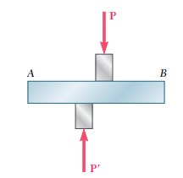 | 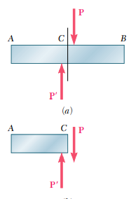 | $$shear stress=\frac{P}{A}=\frac{F}{A}$$
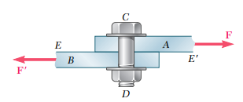 | 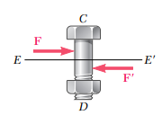  $$single shear$$ | 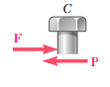
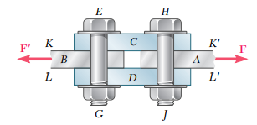 | 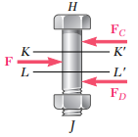$$double shear$$ | 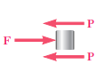$$shear stress=\frac{F}{2A}=\frac{P}{A}$$
$$Bearing stress=\frac{P}{td}$$ | 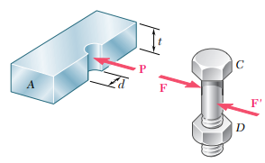 | 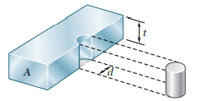

Example 2  Determine the average shear stress in the $20 mm$ diameter pin at $A$ and the $30 mm$ diameter pin at$B$ that support the beam in the figure. | 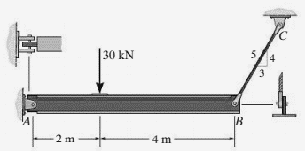
Let us find out the forces acting on the pins by considering the free body diagram of the beam.  $$ΣM_{A}=0 ≫ F_{B}\sin{θ}×6m-30 kN×2 m=0≫≫F_{B}=12.5 kN$$  $$ΣF_{x}=0 ≫≫ {-X}_{A}+F_{B}\cos{θ}=0≫≫X_{A}=7.5 kN$$  $$ΣF_{y}=0 ≫≫ Y_{A}+F_{B}\sin{θ-30 kN}=0≫≫Y_{A}=20 kN$$  The resultant force exerted by pin $A$ on the beam,  $$F_{A}=\sqrt{{7.5}^{2}+{20}^{2}}=21.36 kN$$ |  | 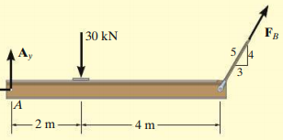  $$Y_{A}$$  $$X_{A}$$

The same force $F_{A}$ acts on the pin in the opposite direction. Now, we can see that the pin at $A$ is in double shear and the pin at $B$ is in single shear. | 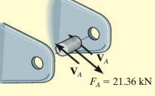 | 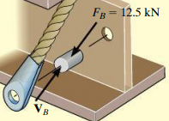
The average shear stress on pin $A$, $τ_{A}=\frac{F_{A}}{2×\frac{πd^{2}}{4}}=\frac{21.36 kN}{2×\frac{π{(0.02 m)}^{2}}{4}}=34×{10}^{6}N/m^{2}$
The average shear stress on pin $B$, $τ_{B}=\frac{F_{B}}{\frac{πd^{2}}{4}}=\frac{12.5 kN}{\frac{π{(0.03 m)}^{2}}{4}}=17.7×{10}^{6}N/m^{2}$

Example 3  In the hanger shown, the upper portion of the link $ABC$ is $3/8 in.$ thick and the lower portions are each $¼ in.$ thick. Epoxy resin is used to bond the upper and lower portions together at$B$. The pin at $A$ is of $3/8 in$. diameter while a $¼ in$. diameter pin is used at C. Determine the shearing stress in pin $A$ and $C$, the largest normal stress in the link $ABC$, the average shear stress on the bonded surfaces at $B$, and the bearing stress in the link at $C$. | 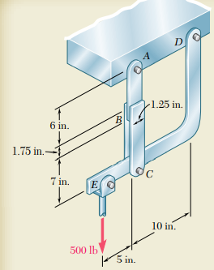  $$1 in.=25.4 mm, 1 lb=4.45 N$$
Consider the free body diagram of the hanger  $$ΣM_{D}=0 ≫ {-F}_{AC}×10 in+500 lb×15 in=0≫≫$$  $$F_{AC}=750 lb=3337.5 N$$  $$ΣF_{x}=0 ≫≫ D_{x}=0$$  $$ΣF_{y}=0 ≫ D_{y}+F_{AC}-500 lb=0≫D_{y}=-250 lb=-1112.5 N$$ | 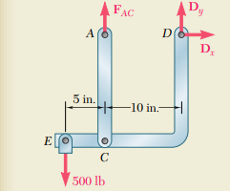

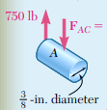 | 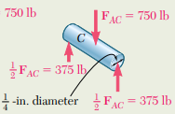 |  | 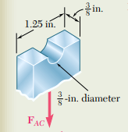
The pin at A is in single shear. The average shear stress on the pin A,  $$τ_{A}=\frac{750 lb}{\frac{π×{\left(0.375 in \right)}^{2}}{4}}$$  $$=6790 psi=46.84 MPa$$ | The pin at C is in double shear. The average shear stress on the pin C,  $$τ_{c}=\frac{750 lb}{2×\frac{π×{\left(0.25 in \right)}^{2}}{4}}$$  $$=7640 psi=52.69 MPa$$ |  | The normal stress in the link ABC is maximum where the cross-sectional area is minimum.  $$σ_{A}=\frac{750 lb}{\left(1.25-0.375\right)in×0.375in}$$  $$=2285 psi =15.77 MPa$$
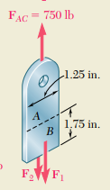 |  | 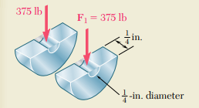
The bonded surfaces are in double shear.  $$τ_{B}=\frac{750 lb}{2×(1.25 in×1.75 in)}=171.4 psi=1.18 MPa$$ |  | The bearing stress in link at C  $$σ_{bearing}=\frac{750 lb}{2×(0.25 in×0.25in)}=6000 psi=41.39 MPa$$

Example 4  An aluminium specimen shown in figure has a diameter $25mm$ and gauge length $250 mm$. If a force of $165 kN$ elongates the gauge length $1.20mm$, determine the modulus of elasticity. Also, determine the contraction in diameter. Take $G_{al}=26 GPa$ and $σ_{yield}=440 MPa$. Calculate the percentage elongation and percentage reduction in area. | 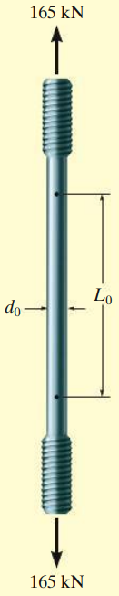
The average normal stress, $σ=\frac{P}{A}=\frac{165×{10}^{3}N}{\left(\frac{π×{0.025}^{2}}{4}\right)m^{2}}=336.1×{10}^{6} Pa=336.1 MPa$
The normal (axial/longitudinal) strain, $ε_{long}=\frac{δ}{L}=\frac{1.2 mm}{250 mm}=4.8×{10}^{-3}$

The stress developed ($336.1 MPa$) is less than the yield stress ($440 MPa$) of the material, it is in the linear elastic range.
Using Hooke’s law, the modulus of elasticity, $E=\frac{σ}{ε}=\frac{336.1×{10}^{6}}{4.8×{10}^{-3}}=70×{10}^{9} Pa$
The shear modulus of aluminium$G=26 GPa$. Using the relation, $G=\frac{E}{2(1+ϑ)}$
$$1+ϑ=\frac{E}{2G}=\frac{70×{10}^{9}}{2×26×{10}^{9}}=1.346 ≫≫≫ ϑ=0.346$$
$$ϑ=-\frac{ε_{lat}}{ε_{long}} ≫≫≫ ε_{lat}=-0.346×4.8×{10}^{-3}=-1.662×{10}^{-3}$$
Change in diameter$=ε_{lat}×d=-1.662×{10}^{-3}×25 mm= -0.0415 mm$
The new length, $L^{'}=L+δ=251.2 mm$
The new diameter, $d^{'}=25-0.0415=24.9585 mm$
% increase in length $=\frac{251.2-250}{250}×100=0.48\%$
% reduction in area $=\frac{\frac{π}{4}{×25}^{2}-\frac{π}{4}{×24.9585}^{2}}{\frac{π}{4}{×25}^{2}}×100=0.332\%$
Example 5  The rigid bar $BDE$ is supported by two links $AB$ and $CD$. Link $AB$ is made of aluminium$(E=70 GPa)$ and has a cross sectional area of $500 {mm}^{2}$; link CD is made of steel $(E=200 GPa)$ and has a cross sectional area of $600 {mm}^{2}$. For the $30 kN$ force shown, determine the deflection of $B, D, and E$ |  |  | 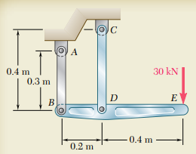
Consider the free-body diagram of bar BDE.  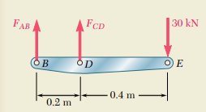 | Consider the bar $AB$  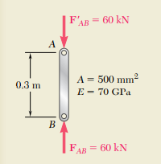 |  |  | Consider the bar $CD$  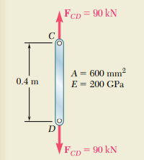
$$ΣM_{B}=0$$  $$F_{CD}×0.2m-30 kN×0.6m=0$$  $$F_{CD}=+90 kN$$  $$ΣF_{Y}=0$$  $${F_{AB}+F}_{CD}-30 kN=0$$  $$F_{AB}=-60 kN$$ | Change in length of $AB$ (displacement of B)  $$δ_{B}=\frac{PL}{AE}=-\frac{60×{10}^{3}N×0.3m}{500×{10}^{-6}m^{2}×70×{10}^{9}Pa}=-514×{10}^{-6}m$$  $$δ_{B}=0.514 mm$$ |  |  | Change in length of $CD$ (displacement of D)  $$δ_{D}=\frac{PL}{AE}=\frac{90×{10}^{3}N×0.4m}{600×{10}^{-6}m^{2}×200×{10}^{9}Pa}=300×{10}^{-6}m$$  $$δ_{D}=0.300 mm$$
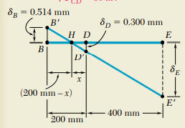 |  | $\frac{BB'}{DD'}=\frac{BH}{HD}≫≫\frac{0.514mm}{0.300mm}=\frac{200mm-x}{x} ≫≫x=73.7 mm$  $\frac{BB'}{EE'}=\frac{BH}{HE}≫≫\frac{0.514mm}{δ_{E}}=\frac{200mm-73.7mm}{400mm+73.7mm} ≫≫ δ_{E}=1.928mm$

Example 6  Determine the elongation of the steel bar $(E=200 GPa, A=500 {mm}^{2})$ which is loaded as shown. | 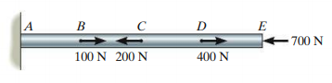  2.5m  1.5m  1.5m  2.5m  R
Consider the free-body diagram of the whole bar. For equilibrium,  $$ΣF_{x}=0$$  $$R+100N-200N+400N-700N=0$$  $$R=400N$$ | 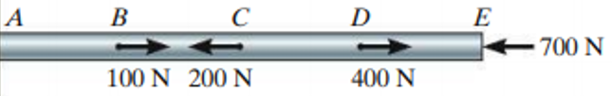  400 N  A
Now, consider the equilibrium of the sections of the bar wherever there is a change in load or cross-sectional area. | R=400 N  B  500 N  300 N  500 N  C  700 N  300 N  E  D  700 N
Part AB: On the left side $R=(400 N→)$. Therefore, on the right side, there should be a force of $400N$ in the opposite direction$\left(←\right)$ for equilibrium.
Part BC: Left side the force should be $(500N→)$so that when we combine $AB$ and $BC$, there will be a net force of $(100N→)$at B. For equilibrium, the force on the right side should be $(500N←)$
Part CD: Left side the force should be $(300N→)$so that when we combine $BC$ and $CD$, there will be a net force of $(200N←)$at C. For equilibrium, the force on the right side should be $(300N←)$
Part DE: Left side the force should be $(700N→)$so that when we combine $CD$ and $DE$, there will be a net force of $(400N→)$at D. The force on the right side is $\left(700N←\right).$
Each segment will have an axial compressive deformation, $δ=\frac{PL}{AE}$
$δ_{AB}=\frac{400N×2.5m}{500×{10}^{-6}m^{2}×200×{10}^{9}Pa}=10×{10}^{-6}m ≪≫ δ_{BC}=\frac{500N×1.5m}{500×{10}^{-6}m^{2}×200×{10}^{9}Pa}=7.5×{10}^{-6}m$
$δ_{CD}=\frac{300N×1.5m}{500×{10}^{-6}m^{2}×200×{10}^{9}Pa}=4.5×{10}^{-6}m ≪≫ δ_{DE}=\frac{700N×2.5m}{500×{10}^{-6}m^{2}×200×{10}^{9}Pa}=17.5×{10}^{-6}m$
Since we are considering deformations in the linear elastic range, we can apply the principle of superposition. Hence, the net deformation will be the algebraic sum of all the individual deformations.
$$δ={-(δ}_{AB}+δ_{BC}+δ_{CD}+δ_{DE})=-39.5×{10}^{-6}m$$

Example 7
Determine the strain energy stored in a prismatic bar suspended from one end due to its own weight, assuming linear elastic behavior.
The strain energy in the linear elastic region, (if load, cross sectional area, and elastic modulus are uniform)
$U=\frac{1}{2}Pδ=\frac{1}{2}P\left(\frac{PL}{AE}\right)=\frac{P^{2}L}{2AE}$ .
The strain energy density,
$$u=\frac{1}{2}σε=\frac{1}{2}σ\left(\frac{σ}{E}\right)=\frac{σ^{2}}{2E}$$
If the load, cross sectional area, and elastic modulus are varying with respect to its length,
$$U=\int_{0}^{L}{\frac{{P_{x}}^{2} dx}{2A_{x}E_{x}}}$$
Let $w$ be the weight density of the material in $N/m^{3}$. Consider an elemental disc of the material having thickness $dx$ at a distance $x$ from the support. The force acting on this element is the weight of the bar below the element.  $$P_{x}=wA(L-x)$$ | x  dx  L
Since the cross sectional area and the elastic modulus are constant
$$U=\int_{0}^{L}{\frac{{P_{x}}^{2} dx}{2A_{x}E_{x}}}=\frac{1}{2AE}\int_{0}^{L}{{\left\{wA\left(L-x\right)\right\}}^{2}dx}=\frac{w^{2}A^{2}}{2AE} {\left[L^{2}x-2L\frac{x^{2}}{2}+\frac{x^{3}}{3}\right]}_{0}^{L}=\frac{w^{2}L^{3}A}{6E}$$

Exercise 1  Two wooden planks, each $22 mm$ thick and $160 mm$ wide, are joined by the glued mortise joint as shown. Knowing that the joint will fail when the average shearing stress in the glue reaches $820 kPa$, determine the smallest allowable length d of the cuts if the joint is to withstand an axial load of magnitude $P=7.6 kN$ | 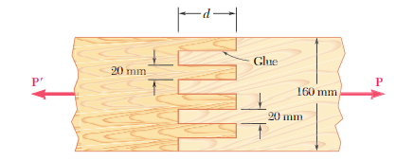
Exercise 2  The rod ABC is made of an aluminiumfor which E=70 GPa. Knowing that P=6 kN and Q=42 kN, determine the deflection of (i) point A and (ii) point B  Exercise 3  What should be the value of Q so that the deflection at A is zero? What will be the corresponding deflection of B? |  |  |  | 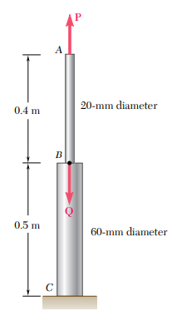
Exercise 4  Link BD is made of brass $(E=105 GPa)$ and has a cross-sectional area of $240 {mm}^{2}$. Link CE is made of aluminium $(E=72 GPa)$ and has a cross-sectional area of $300 {mm}^{2}$. Knowing that they support a rigid member ABC, determine the maximum force P that can be applied vertically at point A if the deflection of A is not to exceed $0.35mm$. |  | 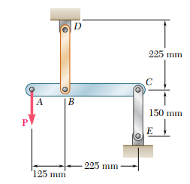
Exercise 5  The stress-strain diagram for an aluminium alloy that is used for making aircraft parts is shown in figure. If a specimen of the material is stress to $600 MPa$, determine the permanent strain when the load is released. Also, find modulus of resilience both before and after the load application |  |  | 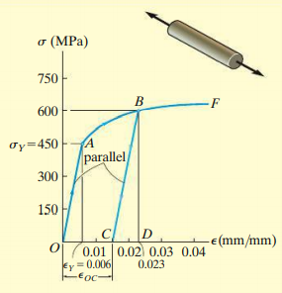

Exercise 6  Aluminium rod, shown in figure has a circular cross-section and is subjected to an axial load of $10 kN$. If a portion of the stress strain diagram is shown, determine the elongation of the road when the load is applied. Take $E=70 GPa$ | 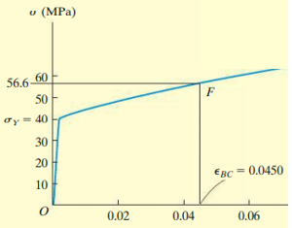
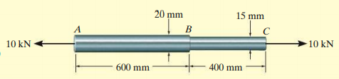
Exercise 7  Determine the elongation of the bar if $E=200 GPa$  $$(1 kip=4.45 kN, 1 in=25.4 mm)$$ |  | 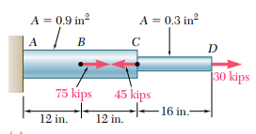
Exercise 8  Determine the elongation of the conical bar due to its self-weight when suspended vertically if the material has a modulus of elasticity $E$ and specific weight $γ$ |  |  |  | 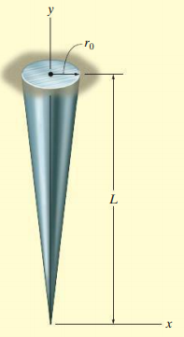
Exercise 9  A 500 mm long, 16 mm long made of a homogeneous, isotropic material is observed to increase in length by $300 μm$, and to decrease in diameter by $2.4 μm$ when subjected to an axial load of $12 kN.$ Determine $E and ϑ$ of the material. |  |  | 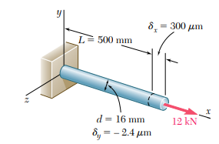
Exercise 10  Determine the strain energy in a prismatic bar suspended from one end, if in addition to its own weight, it supports a load $P$ at the lower end. |  |  | x  dx  L  P

Reference:
- Mechanics of Materials, 2/e, J. M. Gere & S. P.Timoshenko, CBS Publishers.
- Mechanics of Materials, F.P. Beer & E. R. Johnston
- Engineering Mechanics of Solids, 2/e, E. P. Popov, Pearson Education Asia.
- Mechanics of Materials, 9/e, R. C. Hibbeler, Prentice Hall.

